Ichetucknee Springs Trip

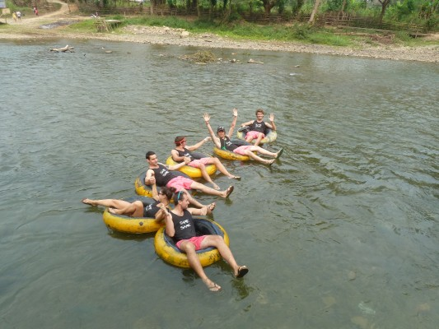

Saturday June 27th
Meet at AA at 7:00, leave at 7:30
620 W. Duval St, Lake City
$17.50 a person, $6 a car entrance fee
Bring towel, sunscreen, lunch/drinks
Questions?
Reach out to 386-344-7766

