What is A.A.?

Alcoholics Anonymous is a fellowship
of men and women who share their experience, strength and hope with each other that they may solve their common problem and help others to recover from alcoholism.
The only requirement for membership is a
desire to stop drinking. There are no
dues or fees for A.A. membership;
we are self-supporting through our
own contributions. A.A. is not allied
with any sect, denomination, politics, organization or institution; does not
wish to engage in any controversy,
neither endorses nor opposes any
causes. Our primary purpose is to
stay sober and help other alcoholics
to achieve sobriety.

Closed meetings are open to
alcoholics and those who think they
might have a problem with alcohol

Open meetings are open to all
who have an interest in the subject.

_________________________________________________________________________________________________________________________________________________________________________________________________________________________________________________________________________________

Get the FREE Meeting Guide App to locate meetings wherever you are.


Or use the QR Code:
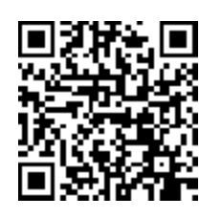
Provided by AA World Services, Inc.

Alcoholics Anonymous

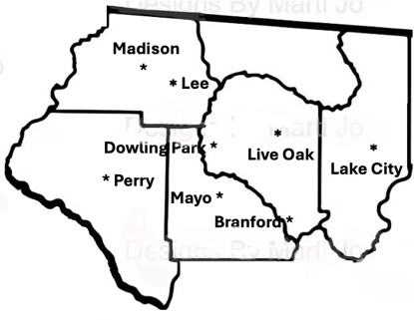

North Florida
District 16
Alcoholics Anonymous
Meeting Schedule

Serving the Counties of:
Columbia, Hamilton, Lafayette,
Madison and Suwannee.

Website: NFAADistrict16.org

If your group’s information has changed
please contact us via the form on the website
or call us at 386-243-5374.

As of 6/15/2026

Branford
Live and Let Live Meeting
Public Library
703 NW Suwannee Ave, Branford FL 32008
Wednesday 6:30pm Open Discussion
352-226-0008

Dowling Park
Beginners AA at Dowling Park
The Lighthouse
23594 CR 250, Live Oak FL 32060
Monday 7pm Open Beginners Meeting
305-407-0895

Lake City
Living Sober Group
620 W Duval St, Lake City Fl 32025
(Behind the Boy Scout House)
Monday 7am, Noon, 5:30pm (Closed Literature), 8pm
Tuesday Noon, 5:30pm, 6:45pm*, 8pm
Wednesday 7am, Noon, 5:30pm, 8pm (Big Book)
Thursday Noon, 5:30pm (Joe & Charlie), 8pm
Friday 7am, Noon, 5:30pm 8pm
Saturday 10:15*, Noon, 8pm Speaker
(Last Saturday of the mo. is anniversary/eating mtg
7pm Eat, 8pm Meet)
Sunday Noon (BB study), 8pm (closed)
Except where noted, meetings are Open Discussion
*Women’s Meetings
386-758-4283

Zoom Online Living Sober Group
Monday - Saturday, Noon
Zoom ID=294354704
Password=sober
386-628-2717

Lake City (Continued)

VA Domiciliary
751 SE Sycamore, Lake City FL 32025
Wednesday 7:30pm Open Discussion
904-534-0164

Welcome Home Group
Spirit of Christ Lutheran Church
145 SW Sweetbreeze Dr, Lake City FL 32024
Monday 6:30pm Big Book Study
Tuesday 6:30pm Literature
Thursday 6:30pm Literature
Last Thursday of the month is Anniversary Dinner at 5:30 with speaker at 6:30
386-804-7467

The Family Afterwards
AA with Al-Anon Participation
Spirit of Christ Lutheran Church
145 SW Sweetbreeze Dr, Lake City FL 32024
Thursday 1:30pm Open Discussion
928-231-2351

Lee
Lee By The Book Big Book Meeting
Lee Library
190 SE County Road 255, Lee FL 32059
Friday Noon Open Big Book Study
727-504-0709

Live Oak
Live Oak Group
Voting Precinct Building
911 Nobles Ferry Rd, Live Oak FL 32064
Tuesday 7am, 7pm Closed Discussion
Wednesday 7am, 7pm Open Discussion
Thursday 7pm Open Book Study
Friday 7pm Open Discussion
Saturday 7pm Open Discussion
Sunday 8am Closed Men’s Discussion
703-403-0745

Madison
Madison Group
St. Vincent Catholic Church
402 Meeting Ave, Madison FL 32340
Tuesday Noon Open Discussion
352-686-7968

Mayo
Mayo Group
3373 East US 27, Mayo FL 32066
(NE corner Hwy 27 and CT 354)
Monday 6:30pm Beginners Meeting
Monday, Thursday 10am Open Discussion
Wednesday 10am Big Book Study
386-867-5953

Perry
Perry Group
Taylor County Senior Citizens Center
800 W. Ash St. Room 3-2, Perry FL 32347
Tuesday 6:30pm Open Discussion
850-838-9255

As of 6/15/2026

